**DBMS CASE STUDY**

**NAME: SAHIL PANDYA**

**ID: 21124097**

**In a University, there are several departments and each department has a head of department who belongs to Faculty. Department have a name, phone extension, specific mailing address and Students that belong to the department. Students can belong to only one Department at a time and Department can have more than one or no Student. Students and faculty have names and unique identification numbers, with address, age , gender and other information. Student studies different Courses offered by University. Faculty teaches these Courses . In each semester one student can take more than one course and Faculty can teach more than one courses . Faculty members can teach in multiple Departments. Each course can be taught by many faculty members or no one. Faculty members are also working on multiple research projects. These projects are funded by government and university. One project can have more than one faculty member and one faculty member can work on more than one project.**

**ENTITIES:**

**Department**

**Faculty**

**Student**

**Course**

**ATTRIBUTES:**

**Department => department_id,   first_name ,   last_name , department_name ,   department_mail ,   department_phone .**

**Faculty =>   faculty_id ,   faculty_name , city , street , pin ,   faculty_contact , faculty_gender , age .**

**Student =>   student_id , first_name , last_name , city , street , pin , student_contact , student_gender , age .**

**Course =>   course_id ,   course_name ,   course_code .**

**ER – DIAGRAM:**

**ER DIAGRAM TO TABLE:**

**1.**

CREATE TABLE department(

department_id INTEGER PRIMARY KEY,

first_name TEXT NOT NULL,

last_name TEXT NOT NULL,

department_name TEXT NOT NULL,

department_mail TEXT NOT NULL,

department_phone INTEGER NOT NULL

);

insert into department values ('101',"Sneha","Patel", "Adminstration", "sneha@gmail.com" , 123456789);

insert into department values ('102',"Suraj","Pandya", "Human Resoures", "suraj@gmail.com" , 123456789);

insert into department values ('103',"Janvi","Doshi", "IT", "janvi@gmail.com" , 123456789);

insert into department values ('104',"Kripa","Shah", "Sales", "kripa@gmail.com" , 123456789);

insert into department values ('105',"Raghav","Agarwal", "Executive", "raghav@gmail.com" , 123456789);

insert into department values ('106',"Hetav","Barot", "Finance", "hetav@gmail.com" , 123456789);

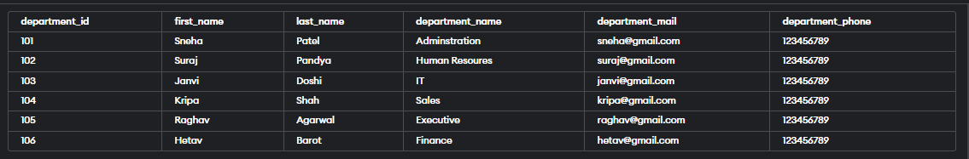SELECT * FROM department;

**2**

CREATE TABLE course(

course_id INTEGER PRIMARY KEY,

course_name TEXT NOT NULL,

course_code TEXT NOT NULL

);

insert into course values ('1', "OOPs", "CS123");

insert into course values ('2', "DSA", "CS124");

insert into course values ('3', "ES", "CS126");

insert into course values ('4', "COMMS", "CS128");

insert into course values ('5', "EG", "CS130");

insert into course values ('6', "DM", "CS132");

SELECT * FROM course;

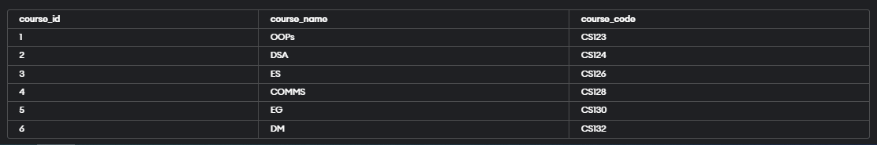

**3.**

CREATE TABLE faculty(

faculty_id INTEGER PRIMARY KEY,

faculty_name TEXT NOT NULL,

city TEXT NOT NULL,

street TEXT NOT NULL,

pin INTEGER NOT NULL,

faculty_contact INTEGER NOT NULL,

faculty_gender TEXT NOT NULL,

age INTEGER NOT NULL

);

insert into faculty values ('501',"HM1","Switzerland","1st street", '98765', 12345678, 'F', 258);

insert into faculty values ('508',"HM2","Brampton"," 2nd street", '13579', 12345678, 'F', 37);

insert into faculty values ('503',"HM3","London"," 3rd street", '24680', 12345678, 'M', 19);

insert into faculty values ('512',"HM4","New Jersey"," 5th street", '12516', 12345678, 'M', 32);

insert into faculty values ('502',"HM5","Massachussetts","4th street", '50000', 12345678, 'F', 26);

insert into faculty values ('505',"HM6","Poland"," 24th street", '97250', 12345678, 'M', 30);

SELECT * FROM faculty;

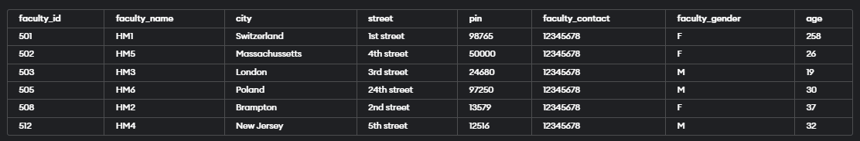

**4**

CREATE TABLE student(

student_id INTEGER PRIMARY KEY,

first_name TEXT NOT NULL,

last_name TEXT NOT NULL,

city TEXT NOT NULL,

street TEXT NOT NULL,

pin INTEGER NOT NULL,

student_contact INTEGER NOT NULL,

student_gender TEXT NOT NULL,

age INTEGER NOT NULL

);

insert into student values ('1',"Sahil","Pandya","Mumbai","Dharavi", 12345, 123456789, "M", 30);

insert into student values ('2',"Chirayu","Doshi","Rajasthan","Udaipur", 12345, 123456789, "F", 20);

insert into student values ('3',"Jayendra","Phadke","Chandigarh","Ramgarh", 12345, 123456789, "F", 23);

insert into student values ('4',"Abhirajsinh","Chauhan","Surat","virpur", 12345, 123456789, "M", 35);

insert into student values ('5',"Vrushank","Shah","Delhi","Sarojini nagar", 12345, 123456789, "F", 20);

insert into student values ('6',"Ruhi","Amin","Jammu","Alinagar", 12345, 123456789, "M", 22);

SELECT * FROM student;

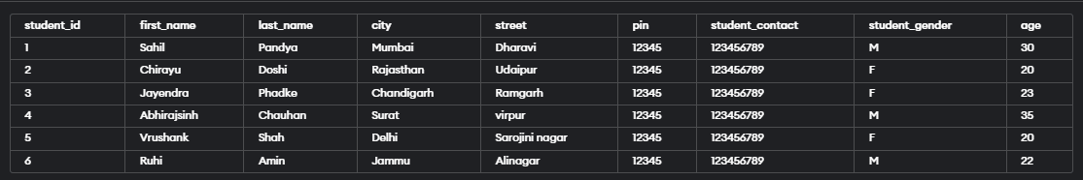

**NORMALIZATION :**

1. **Department**

**Before Normalization**



**After Normalization**

Department{ dept_id, dept_name}

Department{dept_id, f_name, l_name, dept_mail, dept_phone}

|  |  |
| --- | --- |
| Dept_id | Dept_name |
| 501 | Administration |
| 503 | Human Resoures |
| 505 | IT |
| 508 | Sales |
| 509 | Executive |
| 512 | Finance |

|  |  |  |  |  |
| --- | --- | --- | --- | --- |
| Dept_id | F_name | L_name | Dept_mail | Dept_phone |
| 501 | Shaili | Shah |  |  |
| 503 | Rahul | Singh |  |  |
| 505 | Mahima | Rana |  |  |
| 508 | Keya | Shah |  |  |
| 509 | Amar | Bachan |  |  |
| 512 | Jainish | Pathak |  |  |

**2. Course**

**Before normalization**



**After normalization**

Course{ course_id , course_code }

Course{course id , course_name }

|  |  |
| --- | --- |
| **Course_id** | Course_code |
|  |  |
|  |  |
|  |  |
|  |  |
|  |  |
|  |  |

|  |  |
| --- | --- |
| Course_id | Course_name |
|  |  |
|  |  |
|  |  |
|  |  |
|  |  |
|  |  |

**3.  Faculty**

**Before normalization**



**After normalization**

Faculty{ fac_id , fac_name , fac_gender , age}

Faculty { fac_id , city , street , pin }

Faculty { fac_id , fac_contact }

|  |  |  |  |
| --- | --- | --- | --- |
| Fac_id | Fac_name | Fac_gender | age |
|  |  |  |  |
|  |  |  |  |
|  |  |  |  |
|  |  |  |  |
|  |  |  |  |
|  |  |  |  |

|  |  |  |  |
| --- | --- | --- | --- |
| Fac_id | City | Street | Pin |
|  |  |  |  |
|  |  |  |  |
|  |  |  |  |
|  |  |  |  |
|  |  |  |  |
|  |  |  |  |

|  |  |
| --- | --- |
| Fac_id | Fac_contact |
|  |  |
|  |  |
|  |  |
|  |  |
|  |  |
|  |  |
|  |  |

**4.  Student**

**Before normalization**



**After normalization**

Student { stu_id , f_name, l_name , stu_gender , age}

Student { stu_id , city , street , pin}

Student { stu_id , stu_contact}

|  |  |  |  |  |
| --- | --- | --- | --- | --- |
| Stu_id | F_name | L_name | Stu_gender | age |
|  |  |  |  |  |
|  |  |  |  |  |
|  |  |  |  |  |
|  |  |  |  |  |
|  |  |  |  |  |
|  |  |  |  |  |

|  |  |  |  |
| --- | --- | --- | --- |
| Stu_id | city | street | pin |
|  |  |  |  |
|  |  |  |  |
|  |  |  |  |
|  |  |  |  |
|  |  |  |  |
|  |  |  |  |

|  |  |
| --- | --- |
| Stu_id | Stu_contact |
|  |  |
|  |  |
|  |  |
|  |  |
|  |  |
|  |  |